I know the multiplication and division facts for all times tables up to 12 × 12.
The Year 6 children should already know ALL the times tables up to 12x12. The aim is for them to recall these facts instantly. This half term is a chance for Year 6 children to consolidate their knowledge of multiplication and division facts and to increase their speed of recall.

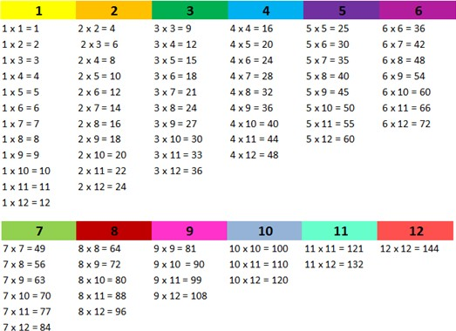 | Key Vocabulary  What is 12 multiplied by  6?  What is 7 times 8?  What is 84 divided by 7?

They should be able to answer these questions in any order, including missing number questions e.g. 7 × ⃝
= 28 or ⃝ ÷ 6 = 7. Children who have already mastered their times tables should apply this knowledge to answer questions including decimals e.g. 0.7 × ⃝ = 4.2 or ⃝ ÷ 60 = 0.7

Top Tips
The secret to success is practising little and often. Use time wisely. Can you practise these KIRFs while walking to school or during a car journey? You don’t need to practise them all at once: perhaps you could start with one particular times tables and ensure they know all of them before moving onto another times table.
Speed Challenge – Take two packs of playing cards and remove the kings. Turn over two cards and ask your child to multiply the numbers together (Ace = 1, Jack = 11, Queen = 12). How many questions can they answer correctly in 2 minutes? Practise regularly and see if they can beat their high score.
https://www.topmarks.co.uk/maths-games/daily10 - Level 6 Multiplication/Level 6 Division

https://play.ttrockstars.com/ - Children should be regularly practising their times tables on TTRS and improving their speed.

I can identify common factors of a pair of numbers.
By the end of this half term, children should know the factors of numbers. The aim is for them to recall these facts fairly instantly.

The factors of a number are all numbers which it can divide into with no remainder.  E.g. the factors of 24 are 1, 2, 3, 4, 6, 8, 12, and 24. The factors of  56 are 1, 2, 4, 7, 8, 14, 28 and 56.  The common factors of two numbers are the factors they share.  E.g. the common factors of 24 and 56 are 1, 2, 4 and 8.  The greatest common factor of 24 and 56 is 8.  Choose 2 other numbers from the times tables. Can your child find the factors, then the common factors and then the greatest  common factor? Repeat! | Key vocabulary  factor common factor multiple  greatest common factor
Children should be able to explain how they know that a number is a common factor.
E.g. 8 is a common factor of 24 and 56 because 24 = 8 × 3 and 56 = 8 × 7.

Top Tips
The secret to success is practising little and often. Use time wisely. Can you practise these KIRFs while walking to school or during a car journey? If your child is not yet confident with identifying factor pairs of a number, you may want to practise this first.
If you would like more ideas, please speak to your child’s teacher. https://www.mathsisfun.com/greatest-common-factor.html http://www.conkermaths.org/cmweb.nsf/products/conkerkirfs.html https://www.topmarks.co.uk/maths-games/7-11-years/multiplication-and-division - lots of games here Choose two numbers between 1 and 144. Take it in turns to name factors. Who can find the most?

