I know the multiplication and division facts for all times tables up to 12 × 12.
The Year 5 children should already know ALL the times tables up to 12x12. The aim is for them to recall these facts instantly. This half term is a chance for Year 5 children to consolidate their knowledge of multiplication and division facts and to increase their speed of recall.

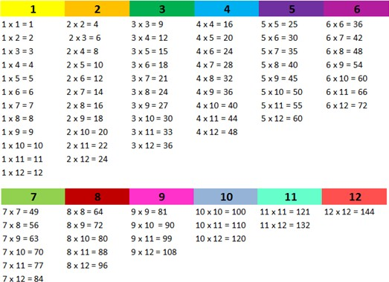 | Key Vocabulary  What is 12 multiplied by  6?  What is 7 times 8?  What is 84 divided by 7?

They should be able to answer these questions in any order, including missing number questions e.g. 7 × ⃝
= 28 or ⃝ ÷ 6 = 7. Children who have already mastered their times tables should apply this knowledge to answer questions including decimals e.g. 0.7 × ⃝ = 4.2 or ⃝ ÷ 60 = 0.7

Top Tips
The secret to success is practising little and often. Use time wisely. Can you practise these KIRFs while walking to school or during a car journey? You don’t need to practise them all at once: perhaps you could start with one particular times tables and ensure they know all of them before moving onto another times table.
Speed Challenge – Take two packs of playing cards and remove the kings. Turn over two cards and ask your child to multiply the numbers together (Ace = 1, Jack = 11, Queen = 12). How many questions can they answer correctly in 2 minutes? Practise regularly and see if they can beat their high score.
https://www.topmarks.co.uk/maths-games/daily10 - Level 5 Multiplication/Level 5 Division

https://play.ttrockstars.com/ - Children should be regularly practising their times tables on TTRS and improving their speed.

I can find factor pairs of a number.
By the end of this half term, children should know the factor pairs of numbers in the times tables. The aim is for them to recall these facts fairly instantly.

Children should now know all multiplication and division facts up to 12 × 12. When given a number in one of these times tables, they should be able to state a factor pair which multiply to make this number. Below are some examples:  24 = 4 × 6 42 = 6 × 7  24 = 8 × 3 25 = 5 × 5  56 = 7 × 8 84 = 7 × 12  54 = 9 × 6 15 = 5 × 3  Choose other numbers from the times tables. Can your child find  some factor pairs? Repeat! | Key vocabulary  Can you find a factor of 28?  Find two numbers whose product is 20.  I know that 6 is a factor of 72 because 6 multiplied by 12 equals  72.
Children should be able to explain how they know that a number is a common factor.
E.g. 8 is a common factor of 24 and 56 because 24 = 8 × 3 and 56 = 8 × 7.

Top Tips
The secret to success is practising little and often. Use time wisely. Can you practise these KIRFs while walking to school or during a car journey? If your child is not yet confident with their times tables, you may want to practise this first.
If you would like more ideas, please speak to your child’s teacher.
Play games - There is an activity at http://www.conkermaths.org/cmweb.nsf/products/conkerkirfs.html
to practise finding factor pairs.
Think of the question – One player thinks of a times table question (e.g. 4 × 12) and states the answer. The other player has to guess the original question.
https://www.topmarks.co.uk/maths-games/7-11-years/multiplication-and-division - lots of games here
Choose two numbers between 1 and 144. Take it in turns to name factor pairs. Who can find the most?

