I can count up and down in tenths. I can recognise decimal equivalent of tenths.

By the end of this half term, children should know the following facts. The aim is for them to recall these facts instantly.

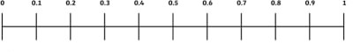

You might use a number line to help count on/back in steps of tenths.
The children are introduced to the decimal equivalents of tenths:

0.1= 1/10 0.2 = 2/10

0.3 = 3/10 0.4 = 4/10

0.5 = 5/10 0.6 = 6/10

0.7 = 7/10 0.8 = 8/10

0.9 = 9/10 1.0 = 10/10 etc.
Top Tips
The secret to success is practising little and often. Use time wisely. Can you practise these KIRFs while walking to school or during a car journey? You don’t need to practise them all at once but instead choose to focus on different aspects at different times.
Games: Make decimal and fraction equivalent cards and play snap/pairs. https://www.topmarks.co.uk/maths-games/daily10 - fraction/decimal sections

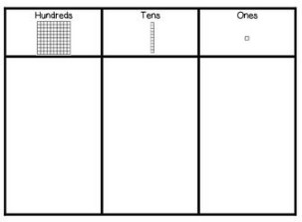

I can multiply and divide 1 digit numbers by 10.
By the end of this half term, children should know the following times. The aim is for them to recall these
instantly.

Multiplying by 10:

When you multiply by 10, the digits move one place to the left.

3 x 10 = 30

6 x 10 = 60

8 x 10 = 80
Dividing by 10:

When you divide by 10, the digits move one place to the right.

50 ÷ 10 = 5

90 ÷ 10 = 9

100 ÷ 10 = 10
Key vocabulary
Ten times smaller
Move the digits one place to the left
Ten times bigger
Move the digits one place to the right
Top Tips
The secret to success is practising little and often. Use time wisely! Can you practise these KIRFs while walking to school or during a car journey? You don’t need to practise them all at once but instead choose to focus on different aspects at different times.
Games: https://www.topmarks.co.uk/maths-games/hit-the-button - x and ÷ by 10 sections

