Dear Parents and carers,
KIRFs (Key Instant Recall Facts) are designed to support the development of the mental skills that underpin much of the maths work in schools. They are particularly useful when calculating, be it adding, subtracting, multiplying or dividing.

An important part of maths development has always been rote learning of certain maths facts. For many years this has included practising times tables and addition facts, such as number bonds and doubles. Each half term children will be assessed on Key Instant Recall Facts (KIRFs) that will be taught in school but also need to be practised at home as well.

It is important that they know these facts thoroughly and can recall them instantly. Whilst children have a wide range of abilities in mathematics, the KIRFs are designed to be a set of facts that need to be learnt thoroughly as they build on each other - year on year. Again, we stress that the children must aim to know their KIRFs inside out, back to front and with instant recall.

We strongly encourage you to engage with your children in the learning of their KIRFs and find fun and practical ways to do this. There are many online tools that you can use such as Times Table Rockstars for Years 2-6, Daily ten and Hit the button which can both be found through these web links.

https://www.topmarks.co.uk/maths-games/daily10

https://www.topmarks.co.uk/maths-games/hit-the-button

Children should undertake these regularly as part of weekly homework. You might find that your child may need to work on some of the KIRFs from the previous year as they may not be secure in those yet. We know that, by internalising these key facts which have been carefully structured to build upon each other term by term, year by year, children will leave St. Cleer with a much stronger foundation of mathematical understanding to build upon.

Attached you will find the whole school progression document in addition to your child’s year-group KIRF.

We hope that you enjoy working alongside your children with this mathematics work. Should you have any questions about the KIRFs programme, please do not hesitate to contact the school.

Kind Regards, Mr Hazlewood
Maths Lead

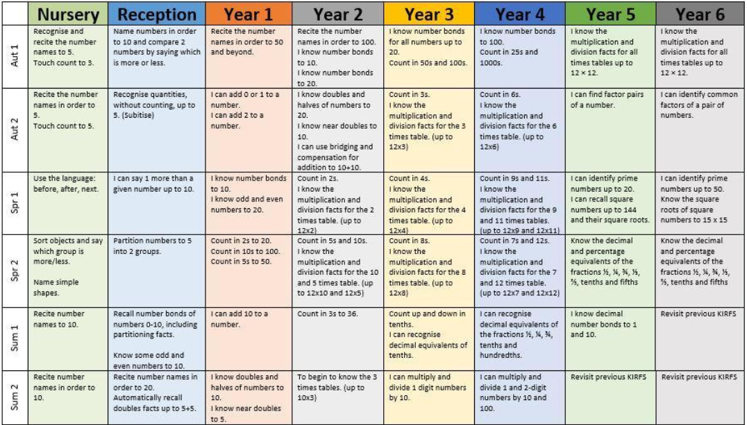
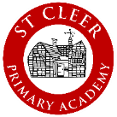
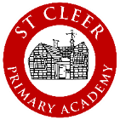
St Cleer Primary Academy - Key Instant Recall Facts Overview

