**R.E**

**What does it mean to be a Hindu in Britain today?**

* Describing Hindu beliefs about God and explain how they worship them
* Finding out about Hindu celebrations (Diwali/ Navaratri/Durga Puja)
* Discussing the importance of Rakshi Bundan for Hindus
* Experiencing and explaining the importance of Rakshi Bundan for Hindus
* Discussing the importance of worship and rituals in the Hindu faith
* Explaining the importance of deities in Hindu worship

**French**

**Phonemes**

* Using phonic sounds/phonemes CH OU ON OI
* Using the phonic sounds/phonemes I IN IQUE ILLE
* Using the phonic sounds/phonemes CH OU ON OI

**Maths**

• Place Value

• Addition, Subtraction, Multiplication and Division

Y3 KIRFS Y4 KIRFS

**English**

**Whole Class Text**: Novel

The Magician’s Nephew – C.S. Lewis

**Traditional Stories:**

• Understanding and interpreting texts

• Identify key features of a traditional tale

**Poetry (creating images):** Haikus/Quick Poems/Kennings

**Whole class reading/Reciprocal Reading:**

Ancient Egypt – Instructions/Information/narrative

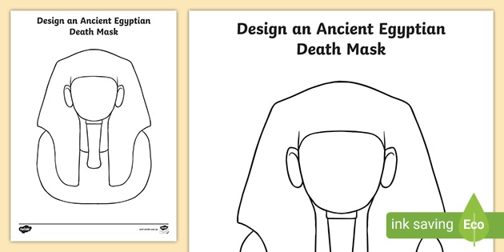

**DT**

**Ancient Egypt**

* Explaining what a shaduf is and its importance Ancient Egypt
* Exploring the history of the shaduf and its purpose
* Designing and create a shaduf
* Evaluating the effectiveness of my design and suggest improvements

**Ancient Egypt**

**(History Focus)**

**Year 3 / 4**

**Autumn Term 1**

***Who were the Ancient Egyptians?***

**Music**

**Developing notation skills**

Q. How does music bring us closer together?

**PSHME**

**Being Me**

* Discussing ways to help others to feel welcome
* Trying to make our school community a better place
* Thinking about everyone’s right to learn
* Showing that I care about other people’s feelings
* Discussing ways in which I can work well with others
* Explaining why following learning Charter/Rules are important

**History**

**Ancient Egypt**

* What we already know about Ancient Egypt
* Explain how we can discover what Ancient Egypt was like over 5,000 years ago
* Discuss and explain how sources of evidence have survived and how they were discovered
* Explain how evidence tells us about everyday life for men, women and children
* Understanding Ancient Egyptians beliefs about life after death

**Computing**

**Computational Thinking + Programming A**

* Creating a sequence of instructions (an algorithm) for a Dance routine (unplugged activity)
* Becoming familiar with the Scratch software
* Investigating Scratch software to create a simple program.
* Writing an algorithm using repetition (unplugged activity)
* Using Scratch software to create programs using loops.
* Using a variety of Scratch activities to embedunderstanding of loops.

**P.E**

**Gymnastics**

* **Finding different ways to take off and land when jumping**
* **Performing sequences linking jumps with a travelling movement**
* **Linking jumps and sideways rolls with quality and body tension**
* **Performing forward rolls**
* **Creating a sequence using apparatus, jumps, rolls and balances**
* **Evaluating your sequence from last week and perform in canon with a partner**

**Science**

**Animals including humans**

* Exploring the 5 food groups
* Understanding that food labels give information on the ingredients in food
* Understanding that animals have different types of skeletons
* Explaining the functions of the human skeleton
* Matching animals to their skeletons
* Exploring the role of muscles